SELECT * FROM EMPLOYEE ORDER BY DEPT_NO ASC, EMP_COMM DESC;

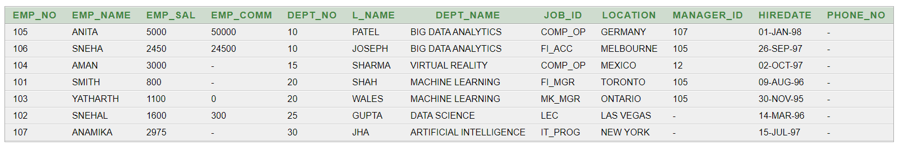

**(21) Update the value of emp_comm to 500 where dept_no is 20.**

UPDATE EMPLOYEE SET EMP_COMM = 500 WHERE DEPT_NO = 20;

SELECT * FROM EMPLOYEE;



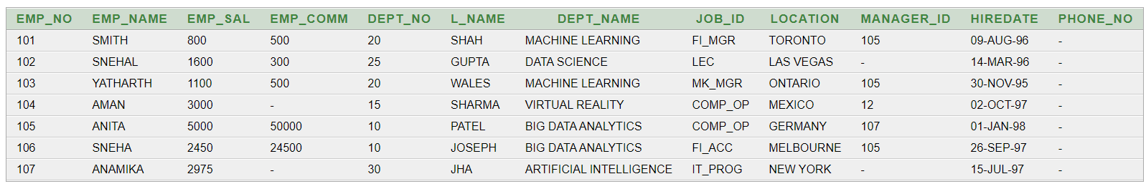

**(22) Display the emp_comm in ascending order with null value first and accordingly sort employee salary in descending order.**

SELECT EMP_COMM, EMP_SAL FROM EMPLOYEE ORDER BY EMP_COMM ASC NULLS FIRST, EMP_SAL DESC;

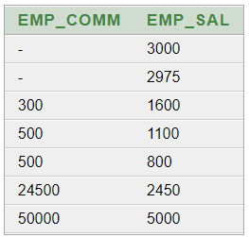

**(23) Display the emp_comm in ascending order with null value last and accordingly sort emp_no in descending order.**

SELECT EMP_COMM, EMP_NO FROM EMPLOYEE ORDER BY EMP_COMM ASC NULLS LAST, EMP_NO DESC;

